Creating variables
To create a variable in Python we use assignment statement which has the following format.
variable_name = expression
The variable_name is the name of the variable, (=) is known as Assignment Operator and expression is just a combination of values, variables and operators. Here is an example:
homerun = 6
This statement creates a variable named homerun and assigns it the value 6. When Python Interpreter encounter statements like this it does the following things behind the scenes.
- Store the variable 6 somewhere in the memory.
- Make variable homerun refer to it.
The important thing to understand here is that variable homerun itself doesn't contain any value, it only refers to a memory location which contains the actual value.
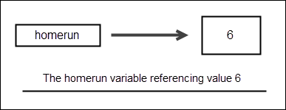
Unlike languages like C, C++, and Java, in Python, we don't declare the type of the variable ahead of time. In fact, it a Syntax error if you try to do so.
1  2  3  4  5  6  7 | >>>  >>> int homerun  File "<stdin>", line 1  int homerun  ^  SyntaxError: invalid syntax  >>>
While assigning a value to the variable, always write the variable name on the left side of the assignment (=) operator. If you don't do this you will get a syntax error as follows:
1  2  3  4  5 | >>>  >>> 100 = words  File "<stdin>", line 1  SyntaxError: can't assign to literal  >>>
Python automatically detects the type of the variable and operations that can be performed on it based on the type of the value it contains. In programming jargon this behavior is known as Dynamic Typing. It means that we could use the same variable to refer to a data of completely different type than it initially points to. For example:
1  2  3  4  5  6  7  8  9  10  11  12  13  14  15  16  17 | >>>  >>> homerun = 6 # at this point, homerun contains an int or integer  >>> homerun  6  >>> homerun = "now" # now homerun contains a string  >>> homerun  'now'  >>>  >>> type(homerun)  <class 'str'>  >>>  >>> homerun = 2.3 # now homerun contains a float  >>> homerun  2.3  >>> type(homerun)  <class 'float'>  >>>
When we assign a new value to a variable the reference to old value is lost. For example, when "now" is assigned to the homerun, the reference to value 6 is lost. At this point, no variable is pointing to that memory location. When this happens Python Interpreter automatically removes the value from the memory through a process known as garbage collection.
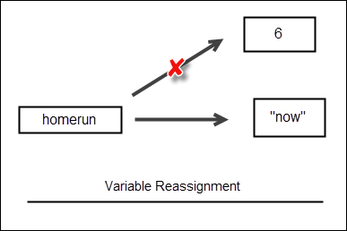
If you try to access a variable before assigning any value to it. You will get NameError error like this:
1  2  3  4  5  6 | >>>  >>> age  Traceback (most recent call last):  File "<stdin>", line 1, in <module>  NameError: name 'age' is not defined  >>>
We can use also use print() function to print the value of a variable like this:
1  2  3  4  5 | >>>  >>> age = 100  >>> print(age)  100  >>>

